**Java Script Complex Assignment**

**16. Reversing an array**

1. Create a function named reversePlusOne. This function should:
   * Take one argument, an array of at least two numbers.
   * This function should return:
     + the array *reversed* with a 1 added at the front

For example:

reversePlusOne([1,2]); // returns [1,2,1]

reversePlusOne([5,4,3,2]); // returns [1,2,3,4,5]

<html>

<h3>Array Quantity plus one</h3>

<body>

<p id="demo"></p>

<script>

document.getElementById("demo").innerHTML=quantityplusone([5,4,3,2]);

function quantityplusone(array)

{

array.reverse();

array.unshift(1);

return (array);

}

</script>

</body>

</html>

**Ans:**

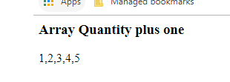

1. Create a function named plusesEverywhere. This function should:
   1. Take one argument, an array of at least two numbers.
   2. This function should return:
      1. a String made of all the values in the array separated by +

For example:

plusesEverywhere([1,2,3]); // returns "1+2+3"

plusesEverywhere([18,24]); // returns "18+24"

<html>

<h3>Pluses everywhere</h3>

<body>

<p id="demo"></p>

<script>

document.getElementById("demo").innerHTML=quantityplusone([1,2,3]);

function quantityplusone(array)

{

return array.join("+");

}

</script>

</body>

</html>

**Ans:**

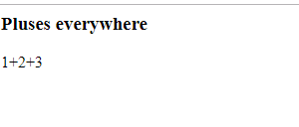

1. Create a function named arrayQuantityPlusOne. This function should:
   1. Take one argument, an array of numbers.
   2. This function should return:
      1. one greater than the number of items in the array

For example:

arrayQuantityPlusOne([0,0,1,0,2,1]); // returns 7

arrayQuantityPlusOne([42]); // returns 2

<html>

<h3>Array Quantity plus one</h3>

<body>

<p id="demo"></p>

<script>

document.getElementById("demo").innerHTML=quantityplusone([0,0,1,0,2,1]);

function quantityplusone(array)

{

return (array.length+1);

}

</script>

</body>

</html>

**Ans:**

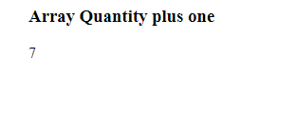

# Object Oriented Basics

17. Complete the createCourse function. This function should:

* + take three arguments that will define course properties
    - courseTitle (string)
    - courseDuration (string)
    - courseStudents (array)
  + return an object that has each property assigned its proper value

For example:

createCourse('Bloc Front-End Engineering', '4 weeks', ['Joe', 'Tim', 'Rob'])

// should return {title: 'Bloc Front-End Engineering', duration: '4 weeks', students: ['Joe', 'Tim', 'Rob']}

<!DOCTYPE html>

<html>

<h3>Create Course</h3>

<body>

<p id="demo"></p>

<script >

var txt="";

var x;

function createCourse(courseTitle, courseDuration, courseStudents)

{

this.courseTitle=courseTitle;

this.courseDuration=courseDuration;

this.courseStudents=courseStudents;

}

var obj= new createCourse('Bloc Front-End Engineering' , '4 weeks' , ['Joe', 'Tim', 'Rob']);

for(x in obj)

{

txt+=obj[x];

}

document.getElementById("demo").innerHTML = txt;

</script>

</body>

</html>

**Ans:**

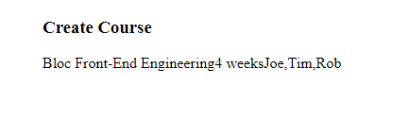

1. Complete the addProperty function. This function should:
   * Take three arguments:
     + object: an object to add a properties to
     + newProp: a property that we want to add to the object
     + newValue: a value that we want the new property to have
   * If object doesn't already have a property named newProp, then add newProp with value of newValue to object
   * If object already has newProp, return the object argument.

For example:

addProperty({}, 'firstName', 'Jim') // should return { firstName: 'Jim' }

addProperty({firstName: 'Rob'}, 'firstName', 'Jim') // should return {firstName: 'Rob'}

<!DOCTYPE html>

<html>

<body>

<h2>JavaScript Functions</h2>

<p id="demo"></p>

<script>

var txt="";

var x;

function addProperty(object, newProp, newValue){

if(!object.hasOwnProperty(newProp)){

object[newProp] = newValue;

}

return object;

}

var obj=new addProperty({}, 'firstName', 'Jim')

for(x in obj)

{

txt+=obj[x];

}

document.getElementById("demo").innerHTML = txt;

</script>

</body>

</html>

**Ans:**

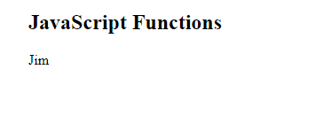

1. Complete the formLetter function. This function should:
   1. take one argument, a letter, which has three properties recipient, sender, and msg
   2. combine the three properties into a single string with an additional greeting and closing
   3. insert additional new lines between the greeting, message, and signature.

For example:

formLetter({ recipient: "James", sender: "Richard", msg: "Things are well." })

// should return "Hello James,\n\nThings are well.\n\nSincerely,\nRichard"

<!DOCTYPE html>

<html>

<body>

<h2>JavaScript Functions</h2>

<p>Functional Constructor</p>

<p id="demo"></p>

<script>

function formLetter(recipient, sender,msg) {

this.recipient= recipient;

this.sender=sender;

this.msg=msg;

}

var s = new formLetter("Karan, "," Arjun","things are well. ")

document.getElementById("demo").innerHTML = "Hello"+" "+s.recipient+" "+s.msg+" "+" Sincerely, "+" "+s.sender;

</script>

</body>

</html>

**Ans:**

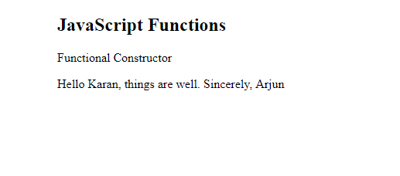

1. Complete the canIGet function. This function should:
   * Take two arguments:
     + item: represents what the user wants to buy
     + money: represents how many dollars a user has
   * return true if a user can afford a given item according to the price chart below, and false otherwise:
     + 'MacBook Air' - $999
     + MacBook Pro' - $1299
     + 'Mac Pro' - $2499
     + 'Apple Sticker' - $1
   * Return false if the item is not in the above list of Apple products

Do this with 0 'if' conditions! (Hint: Place the above price table in an object).

For example:

canIGet('MacBook Air', 100) // returns false

<!DOCTYPE html>

<html>

<h3>Create Course</h3>

<body>

<p id="demo"></p>

<script >

function canIGet(item, money)

{

var itemList = {

'MacBook Air': 999,

'MacBook Pro': 1299,

'Mac Pro': 2499,

'Apple Sticker': 1

};

return itemList[item]<=money?true:false;

}

var obj=canIGet('MacBook Air', 100)

document.getElementById("demo").innerHTML = obj;

</script>

</body>

</html>

**Ans:**

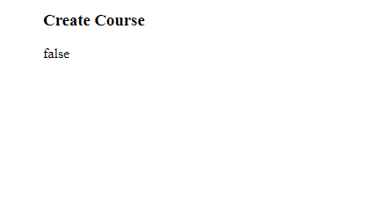

# Strings Assignment

1. Complete the sliceItAndCombineIt function. This function should:
   * take a string and four indices (numbers)
   * return a new string which is the concatenation of two substrings marked by the first and second index of each pair of indices. For example:

sliceItAndCombineIt("This is a Test", 0, 4, 5, 7) // returns "Thisis"

sliceItAndCombineIt("This is a Test", 0, 4, 1, 2) // returns "Thish".

<!DOCTYPE html>

<html>

<body>

<h2>JavaScript Functions</h2>

<p id="demo"></p>

<script>

var sliceItAndCombineIt=function(myString, a,b,c,d){

return myString.substring(a,b)+myString.substring(c,d);

}

document.getElementById("demo").innerHTML = sliceItAndCombineIt("This is a Test", 0, 4, 5, 7);

</script>

</body>

</html>

**Ans:**

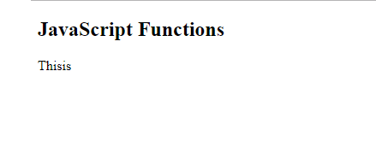

1. Complete the findFirstMatch function. This function should:
   * Take two strings as arguments. The first string is the one to search, the second is the one to search for.
   * Return the position (i.e. index) of the first match of string being searching for

For example:

findFirst("Roses are red", "re") // returns 7 (the position of the "re" in "are")

<!DOCTYPE html>

<html>

<body>

<h2>JavaScript Functions</h2>

<p id="demo"></p>

<script>

var findFirstMatch =function(myString,str){

return myString.indexOf(str);

}

document.getElementById("demo").innerHTML = findFirstMatch("Roses are red", "re");

</script>

</body>

</html>

**Ans:**

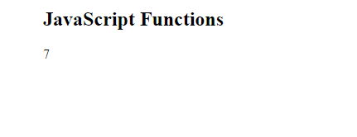

1. Complete the findLastMatch function. This function should:
   1. Take two strings as arguments. The first string is the one to search, the second is the one to search for
   2. Return the position (a.k.a. the index) of the last match of string we're searching for For example:

findFirst("Roses are red", "re") returns 10 (the position of the "re" in "red")

<!DOCTYPE html>

<html>

<body>

<h2>JavaScript Functions</h2>

<p id="demo"></p>

<script>

var findFirstMatch =function(myString,str){

return myString.lastIndexOf(str);

}

document.getElementById("demo").innerHTML = findFirstMatch("Roses are red", "re");

</script>

</body>

</html>

**Ans:**

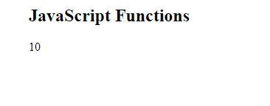

1. Complete the substringBetweenMatches function. This function should:
   1. Take two strings as arguments. The first string is the one to search, the second is the one to search for
   2. Return the substring between the first match and the last match
   3. Not include the first match or the last match in the returned substring For example:

findFirst("Roses are red, apples are really red.", "red") // returns ", apples are really "

<!DOCTYPE html>

<html>

<body>

<h2>JavaScript Functions</h2>

<p id="demo"></p>

<script>

var substringBetweenMatches =function(myString,str){

var strlength=str.length;

var firstsub=myString.indexOf(str)+strlength;

var lastsub=myString.lastIndexOf(str);

return myString.substring(firstsub,lastsub);

};

document.getElementById("demo").innerHTML = substringBetweenMatches("Roses are red apples are really red.", "red") ;

</script>

</body>

</html>

**Ans:**

